MEP processing:

C:\Users\nveit\OneDrive - Northwestern University\Research\GITHUB\Spinal Stim Team Github\TEPs processing

Protocol for collecting MEPs:

* The same number of trials should be collected per current intensity (usually a set of 5 pulses per current intensity)
* Current intensity should be increasing in intervals of 10 mA
* If there is a noisy trial within the set, repeat trial, and write down/ keep track of the trial number that was “bad”
* Save .adicht file in preferred folder and export as “.mat” file

Code assumptions:

* EMG data was collected with Delsys sensors, sampled at 2000 Hz.
* Labchart is triggered by Digitimer to collect for 100 ms (200 points)
* Code assumes that every intensity has the same number of pulses done by same current intensity. The default protocol is 5 pulses per intensity, so it groups the signals in sets of 5. If there are bad pulses, the numbers of those trials should be given to avoid including them and shifting the signals into wrong intensity pulses.
* The MEPs are done in intervals of 10 mA. (Usually: start at 10 mA for 5 pulses, then 20 mA x5, 30 mA x5, etc…)
* Sometimes less than 5 pulses are done, so that is why the code asks how many pulses were done.
* RMT is found as the majority out of the number of pulses > 0.05 mV. (So if 5 pulses, 3 out of 5 pulses should > 0.05 mV)
* Latency is found when the threshold of 3*std(derivative(signal(1:10))) is surpassed. The latency if limited to the ±20 idx points of the clicked latency

**Part 1**

* Select the number of pulses per intensity (usually is 5 pulses per intensity, but sometimes less could be done to make the process faster).
* Input the bad trials separated by comma**,[insert picture of Labchart showing what a bad trial is]**
* Select “.mat” file to be processed

*This part of the code will separate the data into usable pulses per muscle, filter 10-500 Hz, and eliminate bad pulses.*

Possible errors:

* “Not 5 trials per intensity”: the bad pulses were not inputted correctly, check in the .adicht file the bad pulses.

**Part 2**

* A plot showing all the MEPs stacked for a muscle will be shown.

Click “Continue” if there is a visible MEP (SHOULD BE AROUND ~60 in x-axis). What you see around ~40 is the stimulation artifact, which is usually more noticeable for upper leg muscles – HAM, VL, RF).

Click “Skip” if there is not visible MEP around ~60.

If clicked “Continue” – will need to click 3 points of the plot.

1. Begin of MEP (latency – vertical line)
2. 1st peak (green * in plot)
3. 2nd peak (green * in plot)

*The order of max vs min peak does not matter. Just make sure to click on the approximate max or min (it does not have to be exact):*

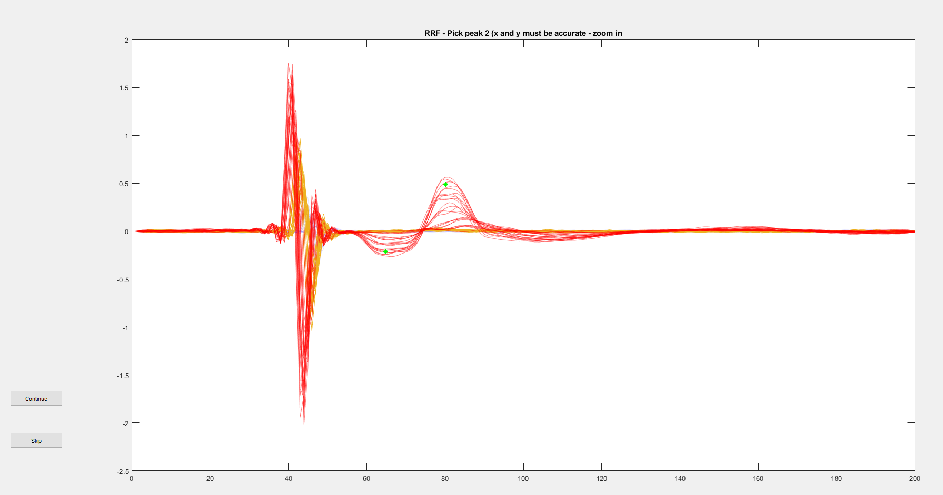

**Part 3**

Calculation of RMT:

* This will save a the RMT, average P2P at RMT, maximum current, and P2P at maximum current for each muscle.

*PICTURE OF OUTPUT:*

*“RMT_table_.....xlsx”*

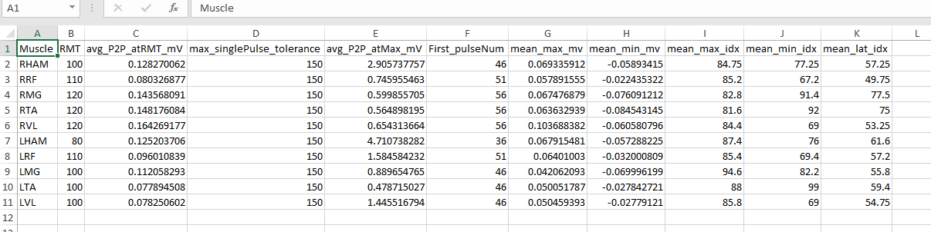

**Part 4**

Plots output:

1. (10) For each muscle, 1 plot showing the average activation at RMT and each of the 5 pulses at RMT. If there was no RMT found, there should not be a plot for that muscle.
2. 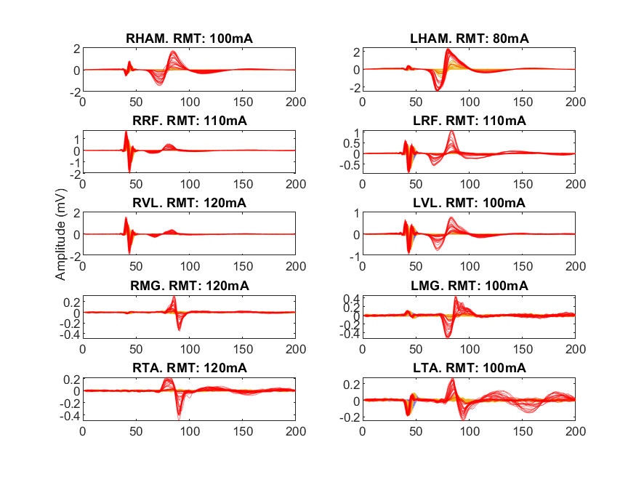(1) 1 subplot showing 10 muscles: MEP outlook – at max activation? Or all overlaid
3. (1) 1 subplot showing 10 muscles recruitment

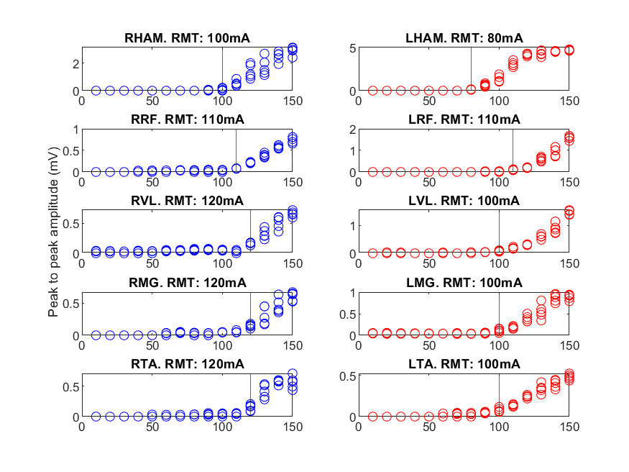

Notice the y axis scale is different for all

Vertical line is the RMT